**LEARNERS ACADEMY Project**

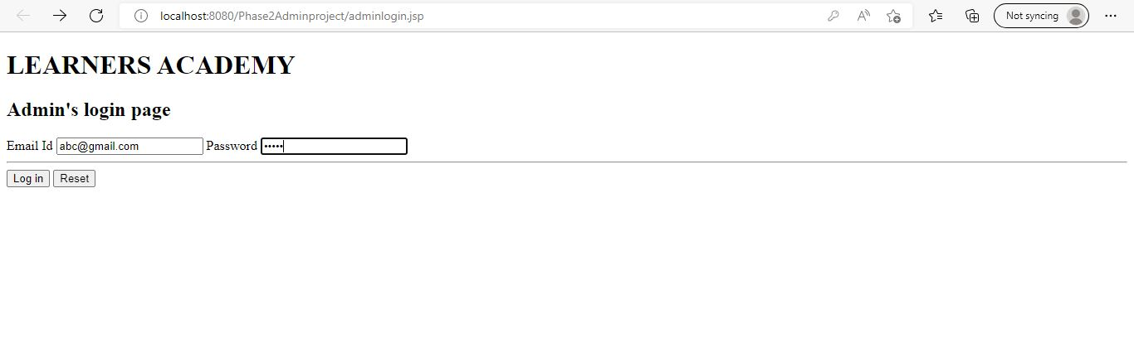

* Only admin can login.
* There is static username and password.

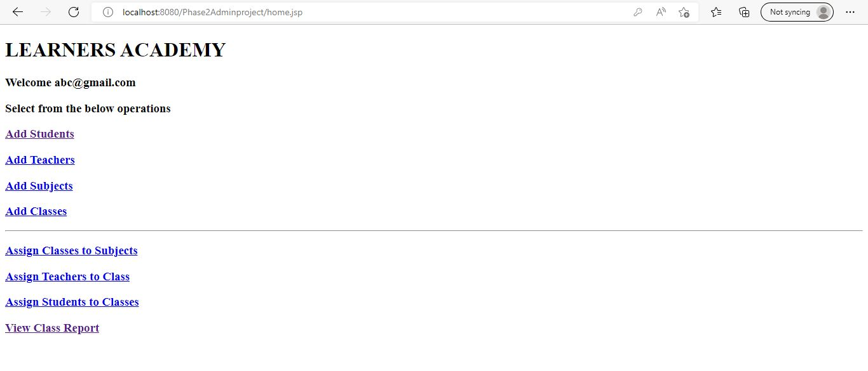

* Above are the options that are available for the admin.
* To add new student, to add teacher, to add subject, to add class, to assign class to subject, to add teacher to class, to add student to class.
* Admin can view the report where result of every option can be visible.

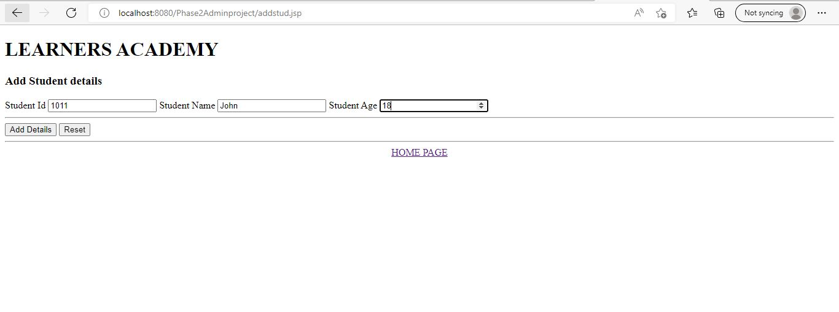

* When admin clicks on add student, this page will be visible.
* Student id, student name and student age details are entered by admin.
* Then details will be added in student table.

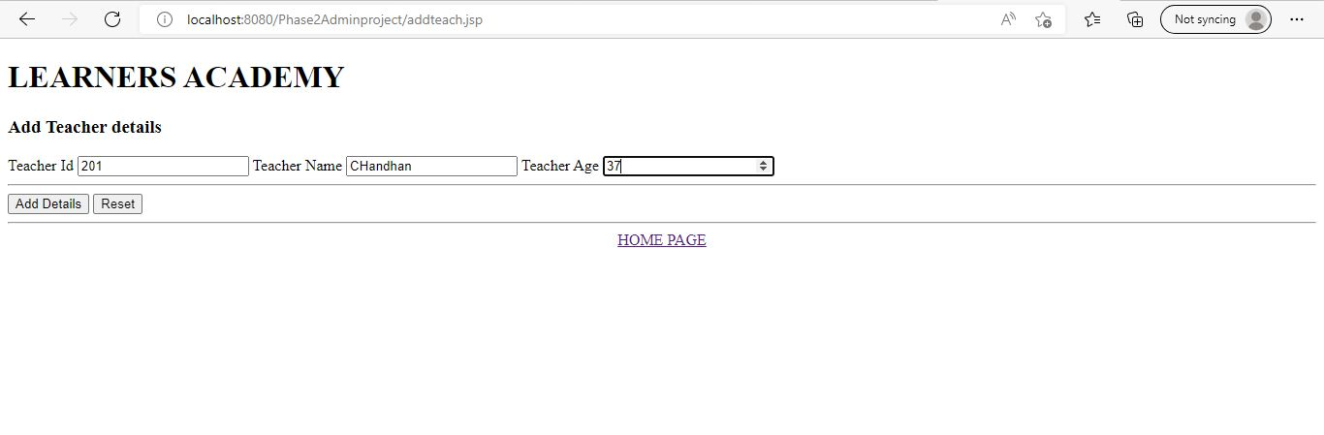

* When admin clicks on add teacher, this page will be visible.
* Teacher id, teacher name and teacher age details are entered by admin.
* Then details will be added in teacher table.

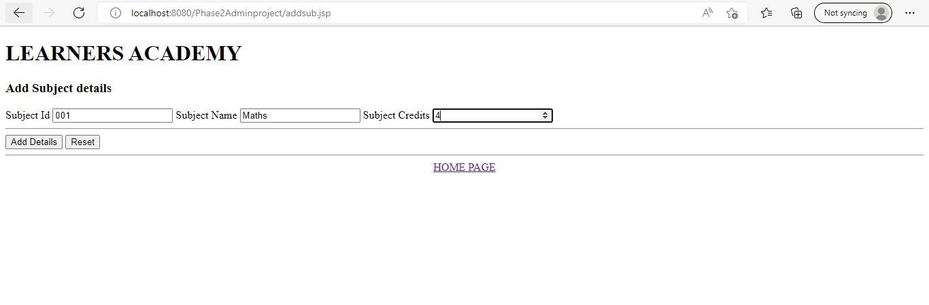

* When admin clicks on add subject, this page will be visible.
* Subject id, subject name and subject credits details are entered by admin.
* Then details will be added in subject table.

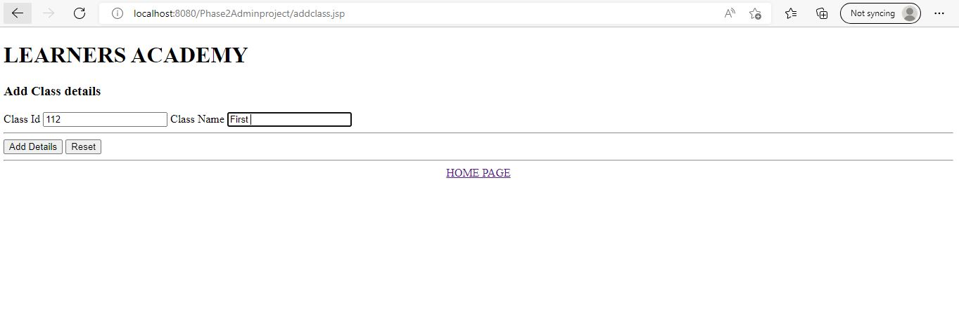

* When admin clicks on add class, this page will be visible.
* Class id, class name details are entered by admin.
* Then details will be added in class table.

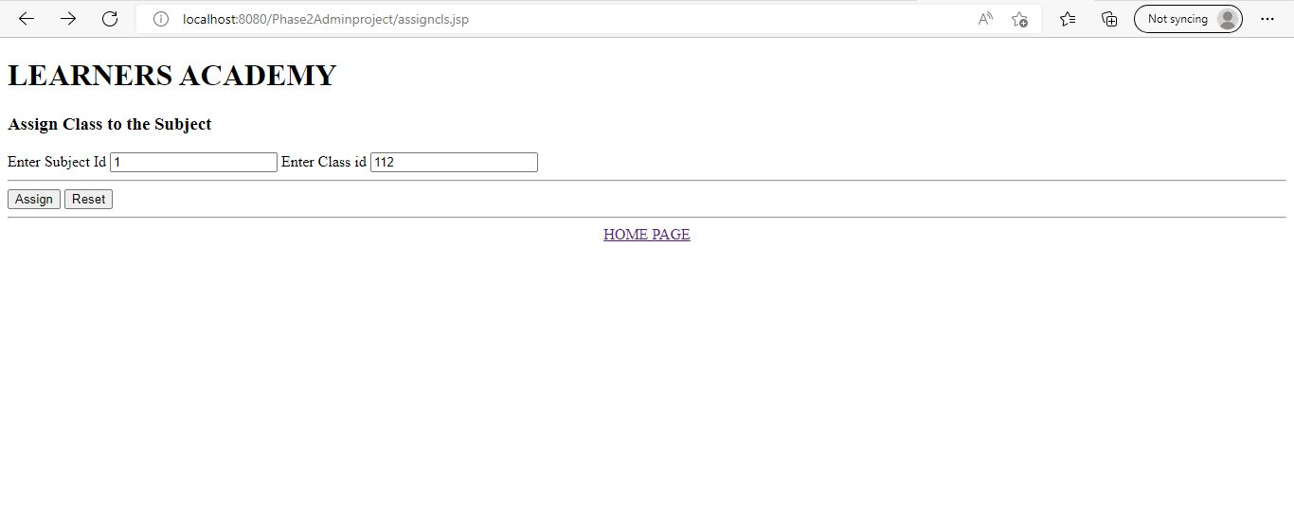

* When admin clicks on assign class to subject, this page will be visible.
* Subject id and class id details are entered by admin.

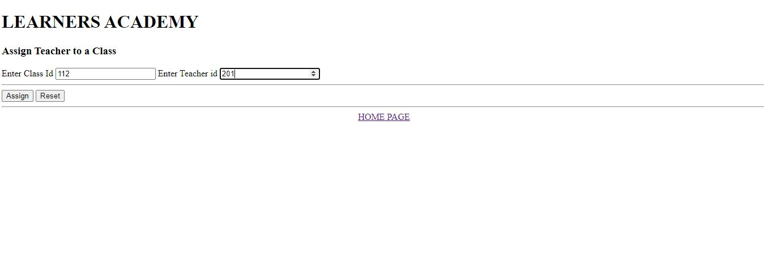

* When admin clicks on assign teacher to class, this page will be visible.
* class id and teacher id details are entered by admin.

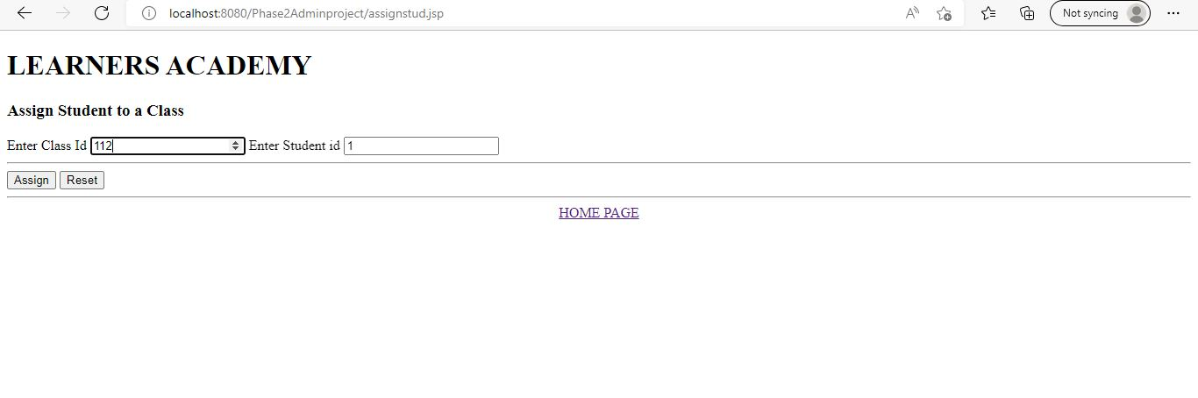

* When admin clicks on assign student to class, this page will be visible.
* Class id and Student id details are entered by admin.

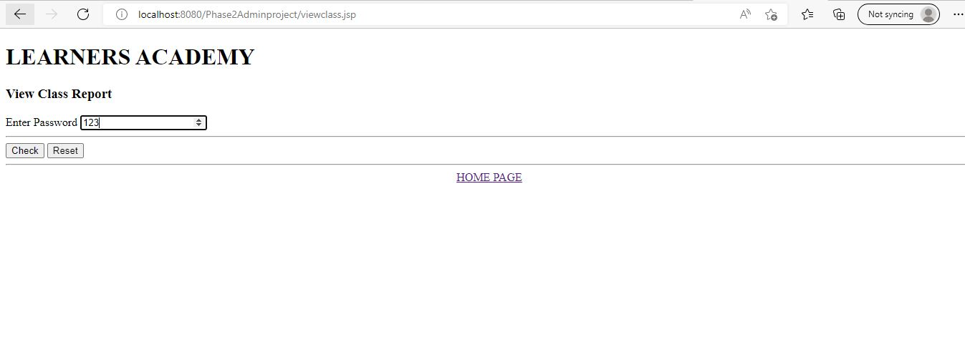

* When admin clicks on view class report, this page will be visible.
* Password need to be entered.

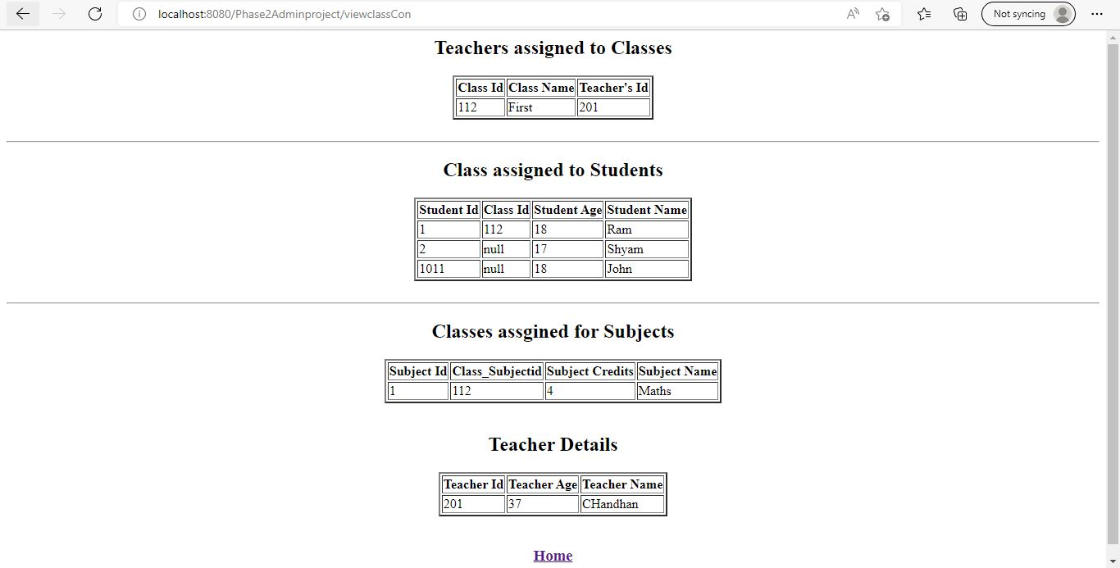

* When admin clicks on view class report, this page will be visible.
* Details will be available about all the tables.